Transform Theory

Introduction

In this section we apply the theorems in the previous sections to explain how the various Fourier transform relationships arise naturally out of the structure of the underlying Hilbert space of the input signal.

Discrete Fourier Transform

A finite discrete time signalhas the property that it is entirely defined by itssamples in the time interval . This range is preferred over because of the complication with odd N. Furthermore, this convention also has a one to one correspondence in with the frequency range , i.e. the lowest and highest frequencies andare mapped toand .
This is the case and . All of the information aboutis contained in the N samples and we expect any representation of must necessarily contain exactlydegrees of freedom. Thus we are in the vector space . The signalbecomes the vector and it may be expanded in terms of a basis exactly of the form. As our basis we choose the set of harmonically related exponential vectors with components . These functions are known collectively as the discrete Fourier basis. The motivation for this choice is that we would like to project the input signal onto a series of “frequencies” instead of directions as in the case for a vector. In this way we decompose x(n) into an equivalent signal whose components represent the frequency content at on of the N specific frequencies. For a signal defined on , only N distinct frequencies , , are possible because . The basis vectors are indeed orthonormal with respect to different harmonic frequencies because

The desired expansion is

where

Notice again, that because of the periodicity of the basis, the expansion is unique only over fundamental interval, and is repeated for adjacent intervals because . Thus both the expansion and the signal may be considered N-periodic so that finiteness is equivalent to periodicity. The coefficient equation can be expressed in terms of the Fourier matrix as

where

However, because the Fourier matrix is symmetric (but not Hermitian) and so that becomes

Also, because the basis functions are orthonormal,, i.e.is unitary, and therefore original signal may be recovered as

In engineering this type of series expansion is known as the discrete Fourier transform (DFT) and is written as

Other common designations for the Fourier matrix areand .

Relationship to Circular Convolution

A circulant system matrixdefined by row vector is diagonalized by the Fourier matrix as

where the diagonal elements of are the DFT coefficients of , i.e.. According to the discussion in () if we appropriately zero pad the lengthinput vector byand the length impulse response permutation vector bythen the matrixhas size . Using the input output relation may be written as

where denotes component wise multiplication between two vectors. Equation says linear convolution may be computed by first zero padding the impulse and input, then multiplying the respective DFTs, and finally taking the inverse DFT of size . This is an important result because the FFT can be used to compute such convolutions speedily.

Fast Fourier Transform

Discrete Time Fourier Transform

The discrete time Fourier transform (DTFT) is a unitary mapping between the class of bi-sequences in and the class of periodic functions, i.e.

A Hilbert space is a complete inner product space.

By complete we mean any sequence converges to a limit that itself is contained in the space.

Any convergent sequence is a Cauchy sequence in

Consider the series of partial sums

if as we say the series converges and we write

Hilbert space of L2[a,b] gives Fourier series in l2[-inf,inf] i.e. continuous non periodic i.e. they are isometric Hilbert spaces

Hilbert space of L2[-inf,inf] gives Fourier transform L2[-jinf,jinf]

N-dim vector space (l2[a,b]), to Fourier transform in N-dim vector space in l2[0,2pi] i.e. discrete periodic

Hilbert space l2[-inf, inf] gives DTFT in L2[0,2pi] i.e. continuous periodic

Bessel’s Inequality

For a finite space, a maximal orthonormal set is a basis and thus any may be expressed as

where. More generally, if we consider any x in X not necessarily in Yn, we can write

where . Thus for the particular choice of we shall obtain a that r=x-y. In otherwords, x will be composed of a portion and. ??????

To prove this we first note, that by orthonormality

Using this we can show

Hence, because r and y are orthogonal we may use the Pythagorean Theorem

to show that because,

for every n=1,2,… These sums have nonnegative terms and thus form a monotone increasing sequence of partial sums that are always bounded by x2. This is the sequence of convergent partial sums of an infinite series, which thus converges.

Let xn be an countable orthonormal set in an inner product space X. Then for any x in X

The series is easily shown to converge for finite n, thus the sequence of partial sums converge for any n, and thus for countable sets.

Lemma. If xn is a countable orthonormal set in a Hilbert space H, then

i) The infinite seriesconverges iff converges.
ii). The representation of any x in H is unique and

proof

i) Suppose is is convergent to x. Then (x,xk)=ak, for all k. Then from Bessel shows converges. Next suppose converges and let, then it follows that, which is finite and thus sn is a Cauchy sequence. Since H is complete, the sequence of partial sums converges and thus the series converges.

ii) Let us first proof .

Fourier Series

L2[a,b] has countable orthonormal set

The set

is orthonormal and maximal with respect to the Hilbert space. Indeed for,

For completeness proof see…
From our discussion on Hilbert spaces above, we know that the set forms a maximal set and thus the Fourier series theorem holds. The coefficients in the expansion are determined from the inner product

which gives rise to the expansion

The doubly (countably) infinite index arises as a result of the specified maximal set. Thus the structure of the complete spanning set determines the index values for the coefficients so that the functional expansion is valid.

Fourier Transform

Almost Periodic Functions

The Fourier transform is a unitary mapping from…. Note that the Hilbert space is nonseparable and thus has an uncountable maximal set. However, from our discussion on Hilbert spaces we know that in any case most of the coefficients will be zero
As an exaple of a Hilbert space which is not separable, one may consider the following function space:

Consider real-valued functions on the real line but, instead of the usual norm, use the following inner product:

The first thing to note about this is that non-trivial functions have norm 0. For instance, any function of has zero norm according to this inner product.
Define the Hilbert space as the set of equivalence classes of functions for which this norm is finite modulo functions for which it is zero. Note that and are orthogonal under this norm if . Hence, the set of functions , where is a real number, form an orthonormal set. Since the number of real numbers is uncountable, we have an infinite orthonormal set, so this Hilbert space is not separable.

It is important not to confuse what we are doing here with the Fourier integral. In that case, we are dealing with , the functions have infinite norm (so they are not elements of that Hilbert space) and the expansion of a function in terms of them is a direct integral. By contrast, in the case propounded here, the expansion of a function of this space in terms of them would take the form of a direct sum, just as with the Fourier series of a function on a finite interval..

Heuristic Derivation from Fourier Series

What follows is the standard heuristic derivation of the Fourier transform based on the Fourier series. The mathematical details involve two theorems from analysis that describe how and why the limiting process is valid. But again, the effort required to grasp these mathematical details does not provide any commensurate increase in understanding of the FT.

Defining and, becomes

where . In the limit as the frequency step size will tend toward the differential, with taking on all values in , so that represents a Riemann sum and passes in the limit to

Similarly, the expression for the “infinitesimal coefficients,” becomes what is known as the Fourier transform

The FT then represents the coefficient or weight or component or amplitude ofat the frequencyand therefore is the frequency spectrum of x. Because of this is known as the synthesis equation and the analysis equation.

Can also be written in terms of angular frequency w=2pif

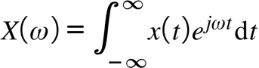

Time Frequency Inverse Duality

If a function has rapid variation in the time domain, we expect that its frequency extent would be large to accommodate the high rate of change. Therefore, a time function that decreases in amplitude over a small extent will have a correspondingly larger frequency extent.

As a function of t, as omega goes up, less area, transform = 0. The higher rate of change of x, more area, more amplitude at a higher frequency., limit w=0 is only dc term, w-inf, get zero, so all ft’s must go to zero at high f.

Alternately, f(x)dx is the amplitude of a cosine of frequency x
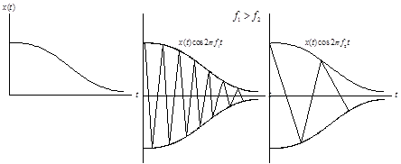
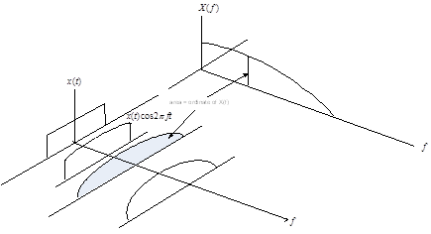

Properties

Time Shifting

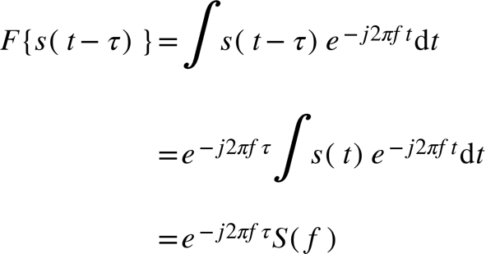

Frequency shift

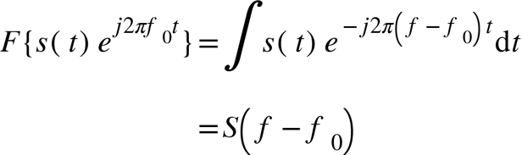

Time Scaling

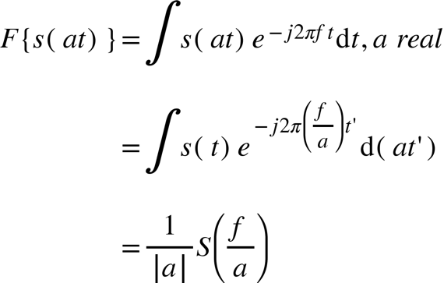

Important Examples

Beats

As the multipath separation increaes, the frequency increases which results in more interference, hence more fading.

Gaussian

where we have completed the square and used the substitution . The contour integral is zero because it has no poles,

The second and fourth integrals decay to zero in the limit, thus we have established the result

which says that over any horizontal line in the complex plane the Gaussian integral is the same, i.e. a constant. The FT is then

The integral may also be accomplished by differentiating () wrt , substituting the series expansion for into () and integrating the resulting expression term by term.

Unit Step Function

limit of generalized function, 1/t.

Rectangular pulse train

The rectangular pulse train of period and pulse width may be expressed as

where

The Fourier series coefficients are

where is the duty cycle. These coefficients are real and symmetric becauseis real and symmetric and represent a sampled sinc function with samples spaced and zero crossing at . Thus as the spectrum becomes continuous and as tends to a constant and the coefficients collapse into a single delta function located at the origin. The Fourier series is

Note that the fundamental harmonic represents the average power contained in ,

Triangular wave

Train of delta functions

Table of Continuous Time Fourier Transforms

L2 functions
Method/Comments
Genralzied functions

Appendix: Cardinality

countable if card(X)<card(N), i.e. integers 1..K.

countable infinite if card(X)=card(N), i.e. Z

uncountably infinity if card(X)>card(N), i.e. [a,b] a, b are rational numbers

Uncertainty Principle

- each t in Ts may be considered a dimension in direct analogy with a vector in a space R, and there are a countable infinite number of them. Each dimension must be represented by a basis so that the projection of the expanded signal is extracted. There must be then an infinite number of basis functions to adequately encompass all of the input signals features. The Fourier basis is a set of harmonically related functions, the negative frequencies are a result of the sum of sines and cosines which are out of phase by 90 deg. The fact that the input signal has an on and off characteristic, i.e. a finite duration, means it must have a transient part and therefore is not a pure tone. A pure tone at a particular harmonic frequency with infinite duration requires only a single basis vector at that frequency because it is
- basis functions are also only of duration T and indexed by k.

Consider a pure sine wave tone. The sound of a flute in its upper register is a pretty good approximation to one. Imagine you have a long recording of it and you cut off a section for the purposes of making measurements on it. If you keep cutting bits off so that you have a shorter and shorter record, you eventually end up with a click. Somewhere in between was a point where you stopped being able to recognise it as a tone, an example of thparadox.
Joseph Fourier (1786-1830) developed his series as a tool for his investigations into heat flow. He showed that any shape of waveform as a graph in time can be created by adding together a series of sine waves. Thus any signal can be fully described (mapped) either by its graph against time or against frequency. A formula known as the Fourier Transform enables us to get one from the other.
In our chopping off process we proceeded gradually from a single frequency sine wave to a click, which has a wide range of frequencies. The sine wave was one precise point in the frequency graph, whereas the click occurs at a precise point in time. In between, we observe that the more we locate a signal in the time domain, the less we can locate it in the frequency domain and vice versa. This is the Uncertainty Principle.
In signal processing we are faced with the problem of taking a finite block of signal and using it to represent the whole signal. This is known as the window problem. The sharp corners of the block, in particular, produce lobes of spurious frequencies that severely contaminate the signal. For this reason we use what are called window functions to smooth out the edges. Thus, in estimating the spectrum of a signal, two workers might get different results depending on their choice of window function. This is also a manifestation of the Uncertainty Principle and we cannot accurately estimate the spectrum of a signal from only part of its time record, though the accuracy improves as the length of our record increases.
Of course, the Uncertainty Principle is most closely associated with Heisenberg in the theory of quantum mechanics. It arises through our difficulties in describing the motion of sub-atomic particles, such as electrons. Our senses can only understand two sorts of motion, that of a particle in which a piece of matter moves, or that of a wave in which the matter stays still on average but the energy moves. The motion of an electron is neither, but if we perform an experiment to look for a particle we see a particle and if we look for a wave we see a wave. The Fourier transform comes into operation because of the wavelike properties and the Uncertainty Principle then becomes The more we know about the position of a particle the less we know about its momentum and vice versa.
The principle is more important in our everyday life, however, in the form associating frequency with time. Consider the problem of fitting a linear trend to a sequence of data. This can be regarded as a signal extraction problem, in which we are trying to extract a ramp or sawtooth component of the signal from the unwanted part, which we call noise. The principle applies. The sawtooth has a precise signature in the frequency domain, but it is contaminated by both the noise and the chopping off distortion.
The dilemma of the global warmers, for example, is that they need to prove that a linear trend is located within the last few decades. If they took only one year’s result it would be like our click, exactly located in time but with infinite errors spread across the frequency domain. As they consider more and more years the errors in the frequency domain decrease, but the event is less and less well located in time. The more accurately they measure the trend, the less accurately they know where it is. This is reflected in the simulations performed in our discussion of fitting linear trends
Naturally, the above verbal discussion is somewhat imprecise and a full explanation would require the use of mathematical language.

Equivalent Widths

A convenient zeroth order measure of the width of a function in the variable

that is, the area of the function divided by its central ordinate. Expressed differently, the equivalent width of a function is the rectangle of height and width whose area is the same as that of the function. This is illustrated in figure ().

Note that this definition holds only for functions with shape such that the ordinate is non-zero. Other definitions of the which are commonly used are the half power width and zero intercept width.

From the relationships

and () we have the reciprocal property

As an example, consider the autocorrelation function of the unit energy waveform ,

which has Fourier transform . From with , and using (unit energy), we find that

In other words, the time interval over which the autocorrelation function has appreciable nonzero value (measured in terms of equivalent widths) is inversely proportional to the frequency extent of the signal.

Because the autocorrelation is the matched filter output for zero-Doppler shift, the above result has applications to signal design for radar and sonar. Typically, the transmitted waveform is time limited to seconds, hence defining the bandwidth measure , we see that the narrowness of the autocorrelation function is inverse to the bandwidth, therefore,

Plancheral’s Power Theorem

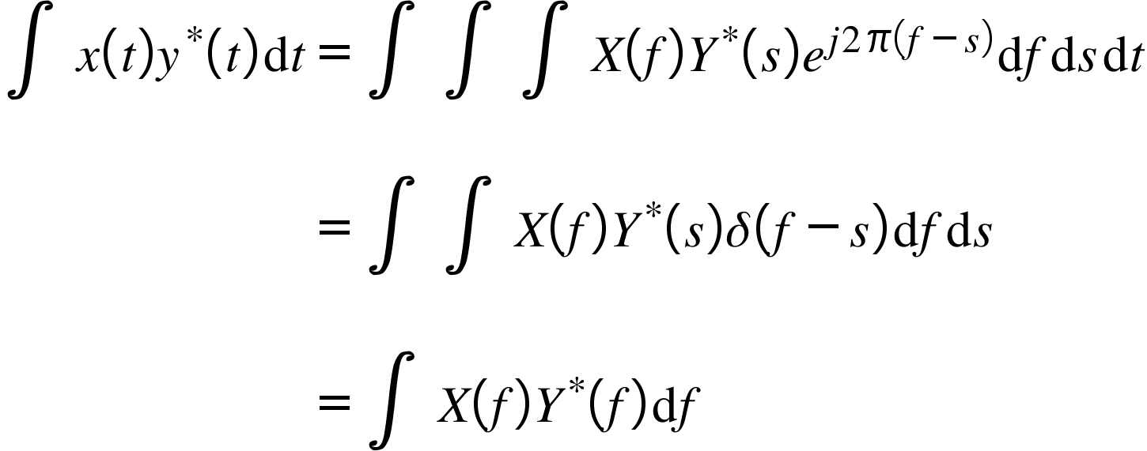

Letting 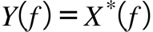, we arrive at Parseval’s theorem

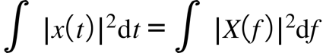

Derivatives

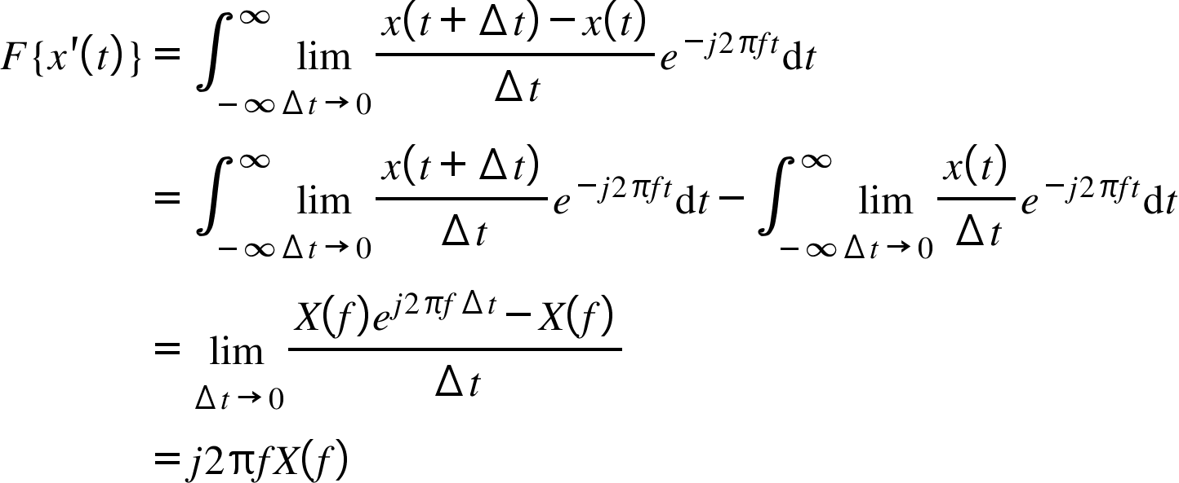

where L’hopitals rule was used in the last step. Integration by parts can also be used. Differentiating n times yields

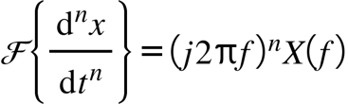

Analogously in the converse domain, we have

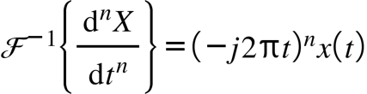

Combining () and the power theorem leads to the Fourier moment integral theorem

z-Transform

After a CT signal is sampled it becomes an N dimensional vector where N is a very large number. In accordance with the Nyquest constraint on the sampling rate we may expect x(n) to have similar frequency characteristics with x(t). How do we extract this information for a DT signal? The answer is the z-transform.

The z-transform derives from the Laurent series representation of an arbitrary complex function analytic in some region about the point . It says that the function of complex argument has the unique representation (one to one mapping) in a region

where the coefficients are merely the samples of . Because the transformation is one to one, any property or characteristic of x(n) is mimicked in X(z), and it is often easier to obtain information about x(n) through its z-transform. The series may be expressed in terms of the causal division

where the second term is known as the unilateral, one-sided or right-sided z-transform suitable for causal signals defined by. When terms for both n<0 and n>0 are present the z-transform is bilateral.

Convergence

In order to obtain the corresponding time series x(n) from X(z) the region of convergence (ROC) must be specified. The ROC is the set of complex numbers z for which the series is valid.

The ratio test can be used to determine the ROC. For any infinite series if the limit exists and is less than 1, i.e.

the series converges. For the z-transform signals are comprised of terms involving for various , so let us postulate the signal

The z-transform reduces to two geometric series with leading ratios and for and , respectively. The global ROC is then the intersection of the two constituent ROCs described by the circles and . This forces so that the ROC is the annulus . The ROC may also be specified in terms of the radius of convergence which are and so that the acronym ROC may refer to either interchangeably.

Inversion

The inversion formula for the Laurent series coefficients is

where is a positive oriented circle inside the annulus of convergence. This is a restatement of Cauchy’s Integral Formula and may be evaluated by residues. Other techniques bypass the contour integral by obtaining the coefficients, i.e. the original signal, directly from the geometric series expansion.

Relationship to DTFT

Here we seek an orthogonal expansion in terms of harmonic frequencies for an infinite discrete time series in exact analogy to the continuous time case. This type of expansion is known as the discrete time Fourier transform (DTFT) . The z-transform provides the route which is motivated by the substitution in. This is equivalent to evaluating exclusively on the unit circle. Therefore, if the ROC contains the unit circle the existence of the DTFT is guaranteed.

The transformation maps a circle in the domain to a line in the domain. This can be seen by equating the real and imaginary parts in the two domains to yield

or and . Because the angle of a complex variable is -periodic, the range must be restricted to an interval of which is the so called principle value. This implies for example thatfor or for . We choose the former, though both ranges are common in the literature. Therefore, as varies from zero to one at a distance from the -axis, traces out a circle radius centered at the origin. In the case of the DTFTand the circle is the unit circle. This leads to the series expansion

The inverse relationship can be obtained from the contour integral in with equal to the unit circle, or from recognizing that is 1-periodic because so that is a Fourier series with coefficients given by

If the principle interval is chosen to be so that , becomes

Again we see that the Fourier transformed signal represents the amplitude at frequencyof the frequency content of the original signal. Because of the periodicity of the basis functions in discrete time, the digital frequency range is limited to which contrasts with the doubly infinite extent in the CT case.

Table of Discrete Time Fourier Transforms

Evaluation technique
Geometric sum formula
Split sum, geometric sum formula

The Laplace Transform

Advantages over Fourier.

Tells about stability because can encompass nonconvgence functions by allowing complex frequency. Ie, can encompass a larger class of functions

Unilateral Laplace Transform
limit as t goes to zero from right, i.e. switch turned on.

The one-sided or unilateral transform of a “well behaved” function is defined as

Convergence

The integral () exists for any t>=0 if

for any complex s satisfying . The number alpha is known as the absissca of convergence. For example, even the Laplace transform of the unstable function converges for because . So that unstable functions in the time domain will have a Laplace transform. In conclusion, the region of convergence is the plane region to the right of the absicisssa.

Example. .

The region of convergence is any Re(s)>0. Using property () , where now requires or which is equivalent to () with .

Inversion Formula

From the inverse Fourier transform formula

and converting to the Laplace domain via the substitution gives

Need to displace bromwich line integral far enough right so that integration is in region of s plane where F(s) converges. Then for complex integration, for t>0 close loop to the left so that e^st goes to zero as Re(s) goes to minus infinity

Bilateral Laplace Transform

To establish the convergence properties of the bilateral transform we write () as

and note that the ROC for the first integral where t>0 is and for the second where t<0 is for some . Therefore if the ROC is the strip of the s plane so delineated.

Example. has the same F(s) as e-at u(t). but ROC s<-a. Thus ROC is necessary to determine F(s)

For inversion via complex integration over contour, close to right so in the limit as t<0, s must go to plus infinity, for semicircle to go to zero.

Transform Properties

Transform Symmetries

Conjugate symmetry for real time signals

Let x(t) have FT X(w) = R(w) +jI(w), magnitude G(w) and phase T(w)

F{x*(t)}=X(w) = X*(-w) then |X(w)| = |X(-w)|, e.g. even magnitude

R(w) + jI(w) = (R(-w) + jI(-w))* = R(-w) -jI(-w), e.g. R is even and I(w)=-I(-w) is odd
Phase T(w) = atan I(w)/R(w), phase T(-w) = atan I(-w)/R(-w) =atan -I(w)/R(w) = -T(w)

Wavelets and other Transforms

Transform Summary Table

